1. 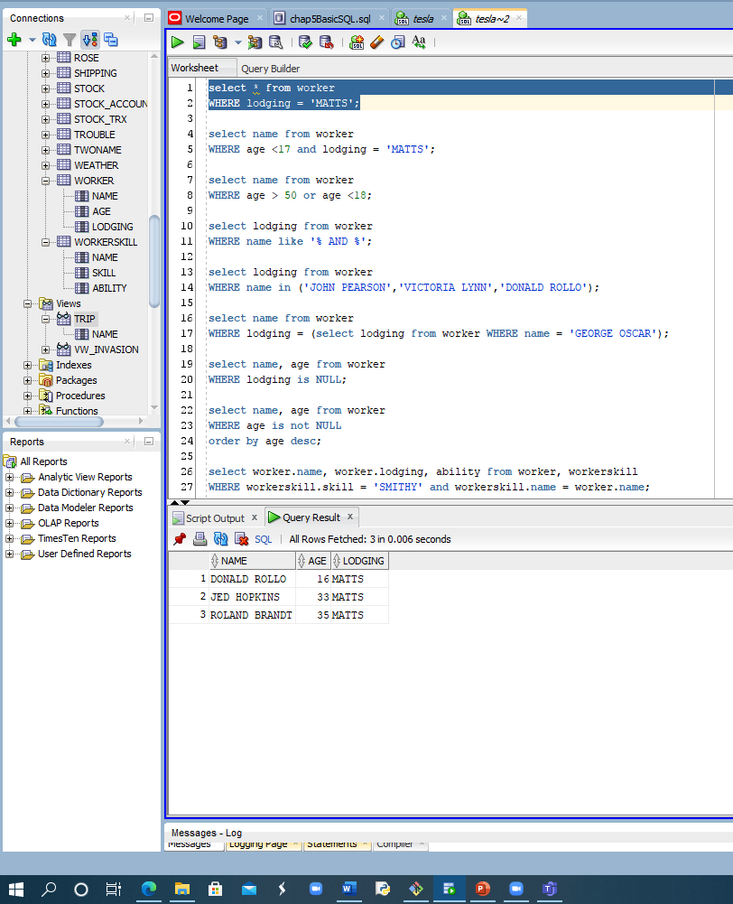This query shows the workers that are currently staying at MATTS.
2. 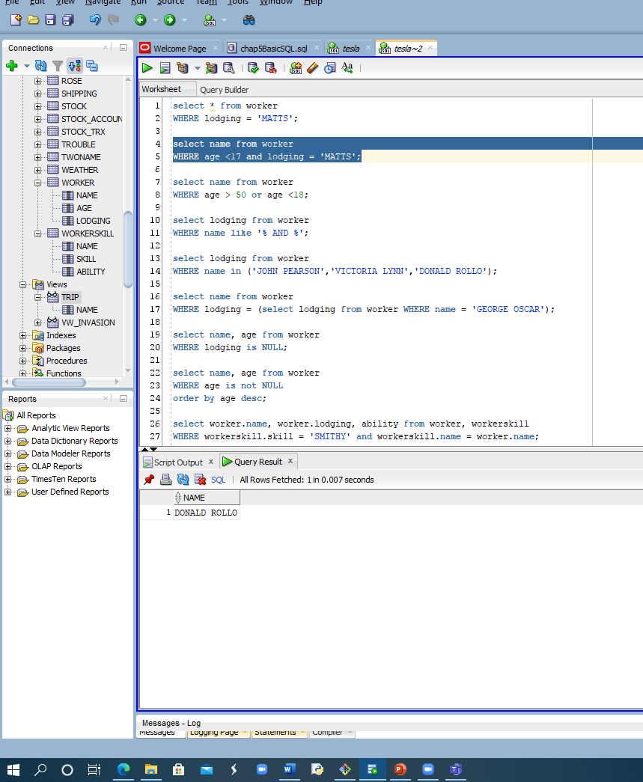This query shows any minors that are staying at MATTS so they can be monitored if needed.
3. 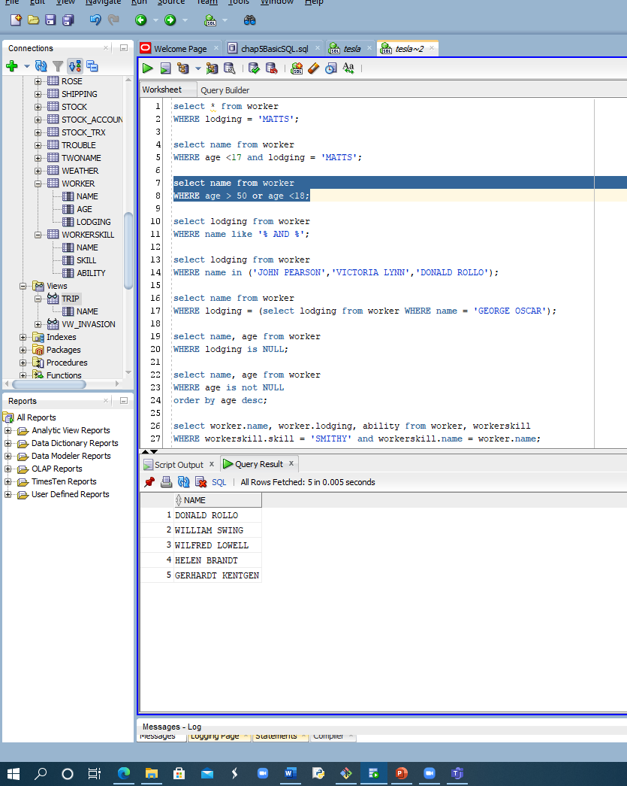This query shows any worker older than 50 or is a minor and can be used to enforce pay cuts if the company is struggling financially.
4. 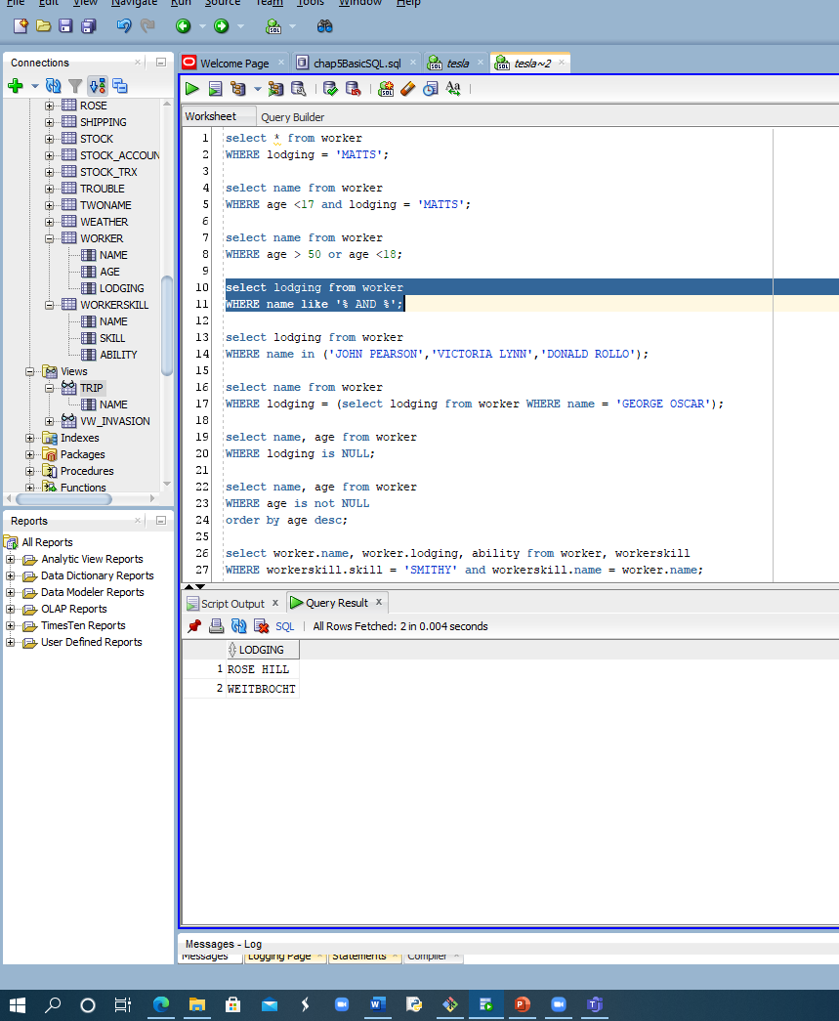This query shows where any group of siblings are staying so the company can easily find them if needed.
5. 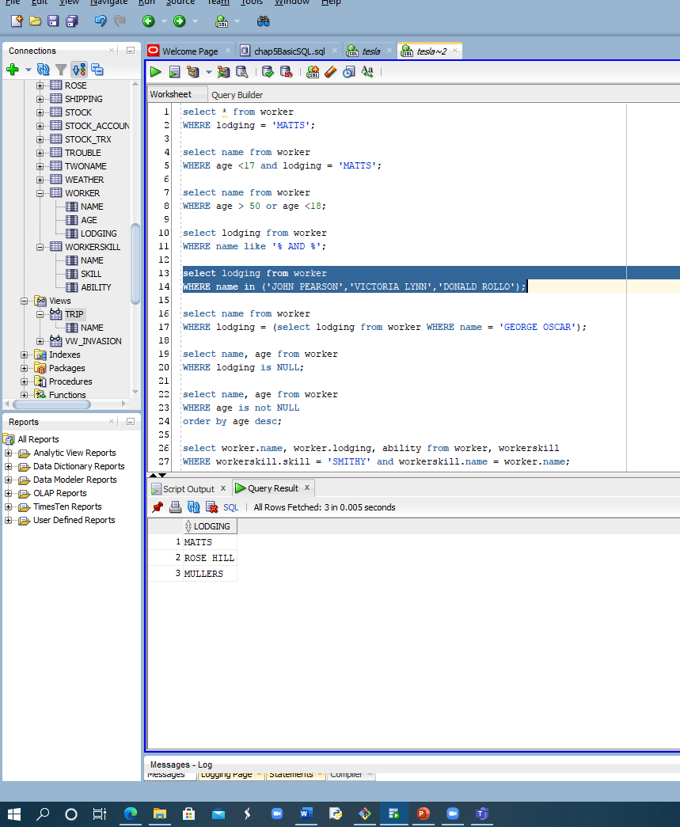This query shows the location of the selected workers for the if the company needs to give them something or track them down.
6. 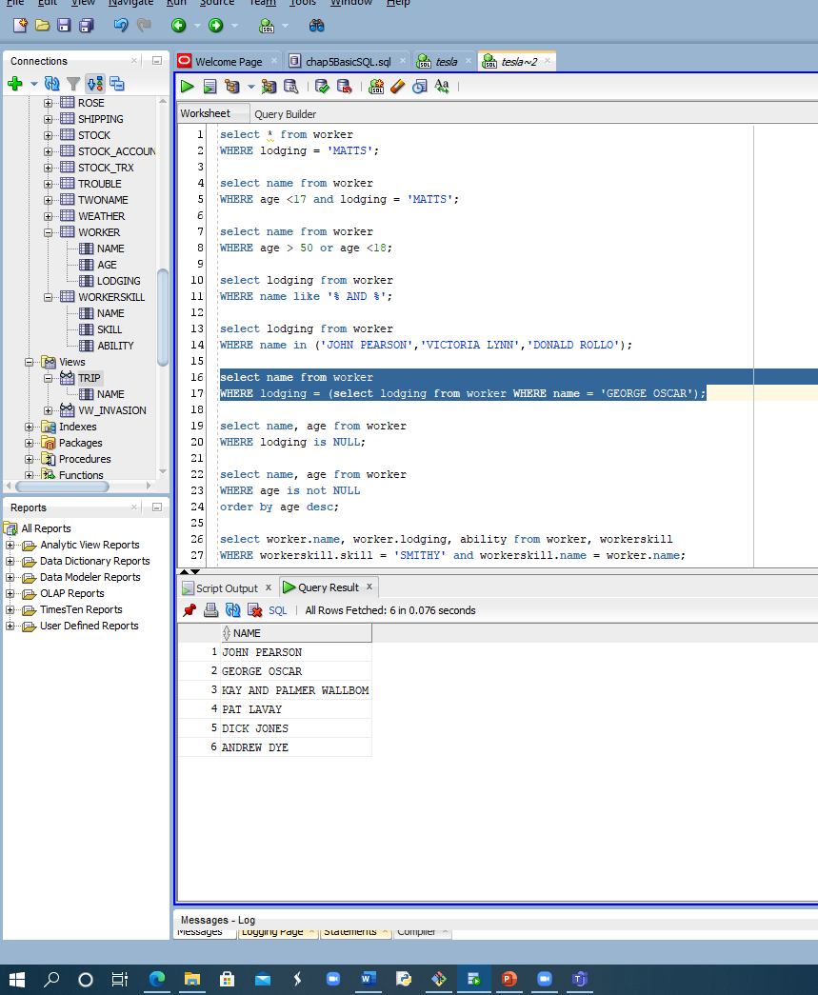This query shows the list of people staying in the same place as George and can be useful isolate those people from the rest of the workers if George is sick with Covid-19.
7. 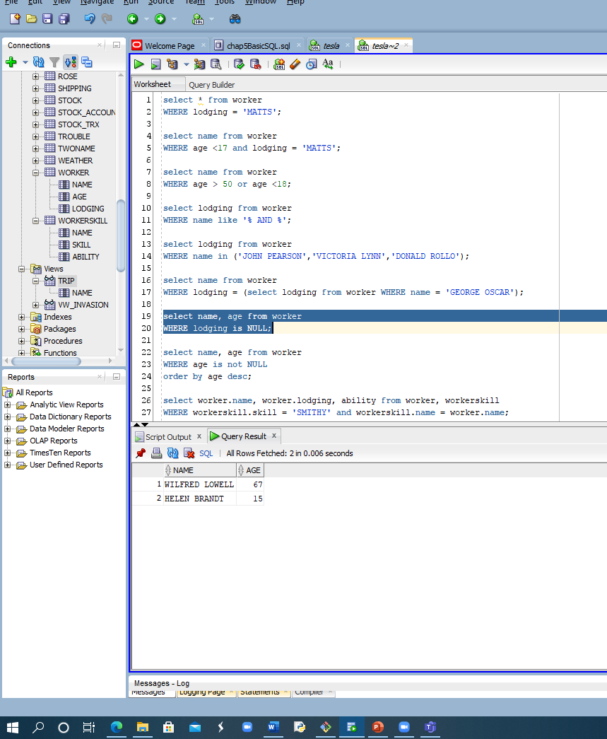This query shows a list of people who are not staying in one of the on site lodging places and it can be used to exclude them from any expenses for the lodging.
8. 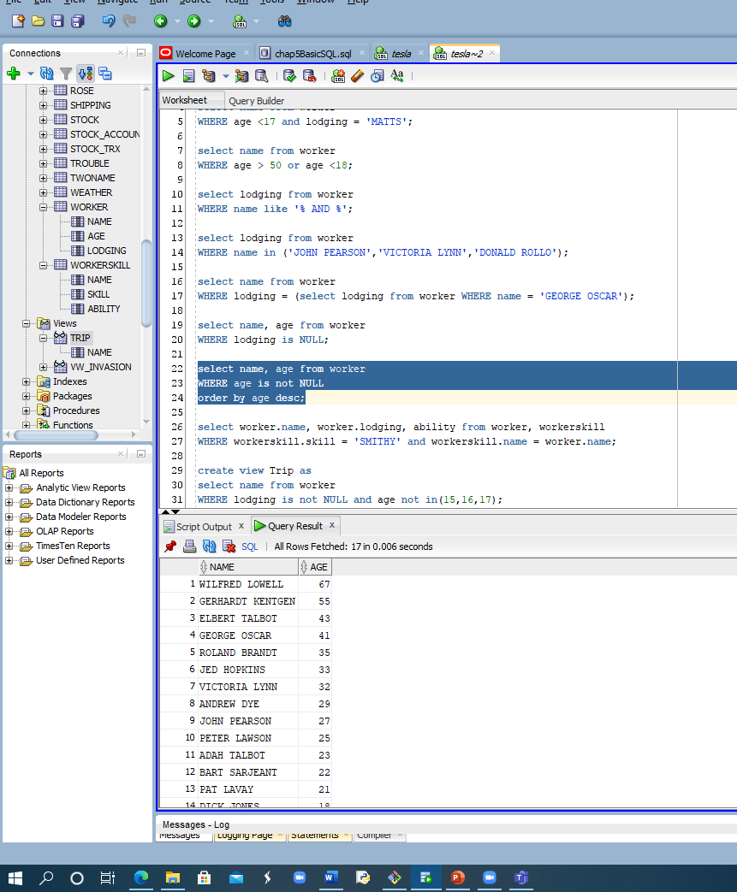This query shows a descending list of workers ages that can be used for seniority.
9. 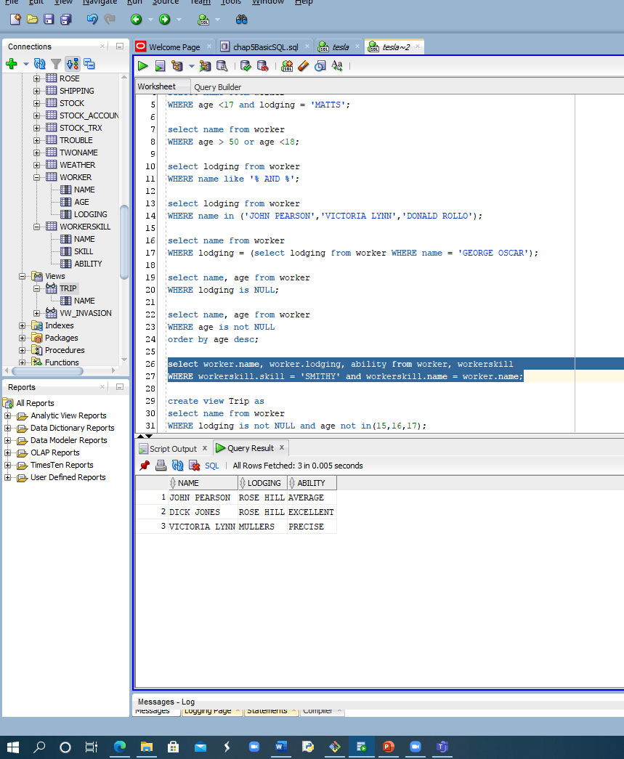This query shows workers whose job is smithing so they can be contacted and assigned jobs according to their ability.
10. 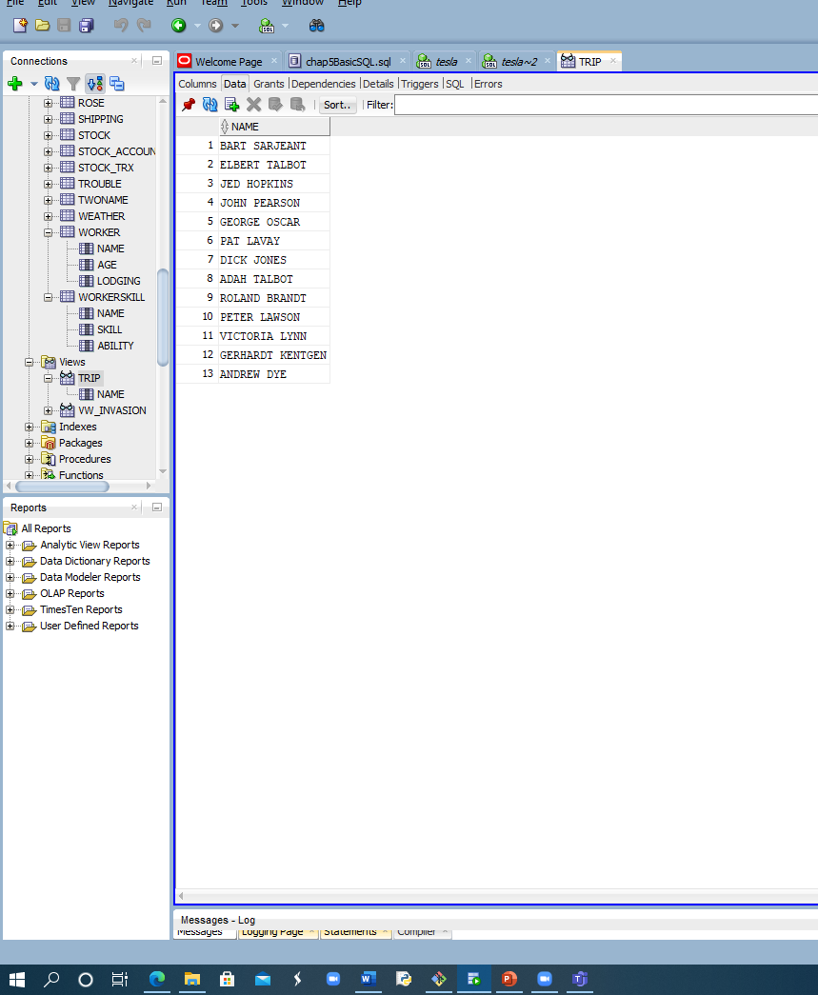This views is a table of a the workers that live in an on site lodging place and are not minors for the purpose of going on a work sponsored trip somewhere.